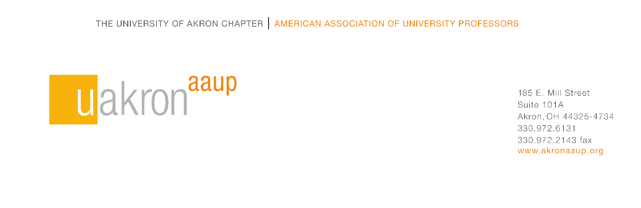
Spring 2022 Chapter Meeting Agenda
18 April 2022
12:00-1:30 p.m.
Zoom Meeting (https://us02web.zoom.us/j/88301477701 )
Meeting ID: 883 0147 7701

I. Call to order: 12h04 by Toni Bisconti

II. Approval of the Agenda

- Ira Sasowsky moved to accept the agenda and Kathleen Clark seconded the motion. The motion passed with unanimous consent.

III. Approval of Minutes from 26 October 2021

- Jeffery Pellegrino moved to approve the minutes and Randy Mitchell seconded the motion. The motion passed with unanimous consent.

IV. Welcome – Toni Bisconti, Psychology, BCAS, President

- Toni Bisconti welcomed everyone and noted it is great to see everyone’s name on her computer screen. She hopes next year all of our chapter meetings will be in-person.

- HB327 (devices concepts bill) has likely dead and has a replacement bill (HB 616) and does not include higher education. There is no higher education bill for divisive concepts.

- Toni Bisconti has spent a considerable amount of time working with the Administration on Shared Governance and the Akron-AAUP now has a voice on many more cross-campus committees.

A. Introduction of Current Chapter Officers & Members of executive Committee
- Jordan Renna, Secretary, Biology, BCAS
- Ira Sasowsky, Treasurer, Geosciences, BCAS
- Randy Mitchell, Liaison Council Member-at-Large, Biology, BCAS
- Scott Bible*, Liaison Council Member-at-Large, Management,
College of Business Administration
- Pam Schulze, Past-President, Social Work and Family Sciences,
College of Health and Human Sciences
- Ed Evans**, Chief Negotiator, Chemical, Biomolecular, and Corrosion Engineering, College of Engineering and Polymer Science
- Brian Bagatto**, Contract Administrator & Grievance Officer, Biology, BCAS
- Victoria England Patton*****, Executive Administrator
- Bill Rich*****, Law School Emeritus, Consultant

B. Grievance Committee: Brian Bagatto (CAGO), Bill Rich (consultant)

C. Communications Committee: Pam Schulze (Chair), Toni Bisconti, Jim Wallace

D. Organizing Committee: Travis Hreno (Chair), Toni Bisconti

E. Diversity: Rob Peralta & Toni Bisconti (Co-Chairs), Amanda Weinstein

V. Treasurer Report – Ira Sasowsky

- Ira Sasowsky noted we have spent a lot of money defending faculty rights. The bulk of our funds originate from member dues. We really appreciate your help increasing our membership as it not only helps with increasing solidarity and strengthening our position with the Administration, but it also helps us cover costs associated with protecting faculty rights.

- Ira Sasowsky shared his screen and presented the 2022 budget along with explanations about each type of expenditure in the budget.

- Pam Schulze moved to accept the proposed budget; Kathleen Clark seconded the motion. There was then a brief discussion regarding the percentage of the dues paid to state and national AAUP, and the impact on our budget of non-members no longer paying fair-share dues, and the need to continue to save funds to pay general counsel when it comes time to negotiate the next collective bargaining agreement. There were no objections and the motion to accept the budget passed with unanimous consent.

VI. Chief Negotiator/LMPC Report – Ed Evans

- Ed Evans reminded the faculty that the Labor, Management and Processes Committee discuss with the Administration faculty issues and if need be, draft MOUs to remedy issues that might arise. Ed highlighted the committee’s discussions regarding workload and workload policies and noted they are in the process of finalizing a workload template that each faculty will have to complete and meet with their chair before the start of the fall semester.

- Scott Randby noted it has been a long time since the contract was codified and wanted to know when there will be progress on implementation of the overload policy in the CBA. Scott is concerned faculty might have to justify their workload to the administration. Ed Evans highlighted the workload plan documents will include to list the activities they are doing to make up the percentage of the load allocated to each of three categories (Research, Service, and Teaching). Once this load has been agreed upon, if the Administration would like to increase a faculty member’s teaching load, they would have to either reduce their work in either Research or Service, or pay that faculty member overload.

- Robert Malik was concerned about merit and how this dovetailed with the new workload document. Ed Evans explained that it is important that every faculty member complete and submit the merit documents. While they are not connected, both need to be completed on an annual basis.

VII. Grievance Officer Report – Brian Bagatto

- Brian Bagatto said we have now completed the grievance process associated with the reduction in force in 2020. Brian and Bill Rich highlighted that Robyn Prichard in the School of Dance has won her grievance and will be reinstated. Brian Bagatto mentioned we are monitoring job postings for similarities to positions of RIF’ed faculty and working on addressing faculty situations in which there are concerns about the new overload policy in the CBA.

VIII. Organizing Committee Report – Travis Hreno

- Victoria England Patton updated the chapter regarding the end of the semester chapter party. Toni Bisconti encouraged everyone to please attend and bring a friend. We are going to have events over the summer. Perhaps a hike organized by Randy Mitchell, Ira Sasowsky will lead a group to explore local rocks, and Tony and Jeffery Pellegrino will be organizing a pickleball game.

IX. Faculty Senate Report – Kate Budd (FS Chair) or Adam Smith (FS Vice-Chair)

- Adam Smith, Vice Chair of faculty senate, provided an update the process of the academic investment committee. This committee provides faculty an opportunity to contribute input on how monies will be used for academic investment across campus. This will be a standing committee of the senate moving forward and it will use the following metrics in the decision-making process. Additionally, these metrics will allow us to benchmark against other universities.

  - Teaching, enrollment, and graduation criteria: Number of faculty in department, number of credit hours taught by faculty in the department, number of degrees conferred, average credit hour per faculty, average degree conferred per faculty member.

  - Financial criteria: Yearly department spending by the general fund, external research expenditures, research expenditures per faculty, labor costs (faculty salary and benefits divided by total credit hours taught), and the cost of instruction (department spending divided by credits taught).

  - Qualitative criteria: How the department contributes to the mission of the University, how the department integrates with other programs, and how the department integrates with the community.

X. New Business

- We need two delegates for the 2022 AAUP Conference and Biannual meeting in December, June 16th through June 19th. We get a detailed budget report as well as participate in a vote regarding the AFT alliance. Scott Bible nominated Toni Bisconti as a delegate. Jenny Stanley nominated herself as a delegate. Katie Stoynoff motioned to close nominations and elect Toni Bisconti and Jenny Stanley; Kathleen Clark seconded. There were no objections to the adoption of the motion and it was approved by unanimous consent.

XI. Good of the Order

- Pam Schulze highlighted our chapter website as a source for access to the meeting announcements and poll results. Pam noted that we need people to run for officer positions. Please contact Pam if you have any questions. Toni Bisconti noted that a sign of strength for the Akron-AAUP is multiple people running for leadership positions.

XII. Adjournment: 1h33

*Non tenure-track faculty
**Non-voting members
*** non-EC Members

